**IMBDB/LIBERTYDB/BAWDB/**

**10.102.123.11/12:**

**Cluster Local Resources of Listeners is INTERMEDIATE**

When we were checking the status of cluster resources, we observed the Target of ora.listener.lsnr (all listeners i.e BAWDB/IMBDB/LIBERTYDB) source is ONLINE but State was showing INTERMEDIATE.

* ora.LISTENER_BAWDB.lsnr >>>>> INTERMEDIATE
* ora.LISTENER_IMBDB.lsnr >>>>> INTERMEDIATE
* ora.LISTENER_LIBERTYDB.lsnr >>>>> INTERMEDIATE

* **Note: This situation is infrequent but can impact the overall cluster health.**

Now, we must check the status of all listeners with cluster level using the commands below.

* lsnrctl status

All the listeners up and running.

We raised a SR to Oracle Support team and discussed with them.

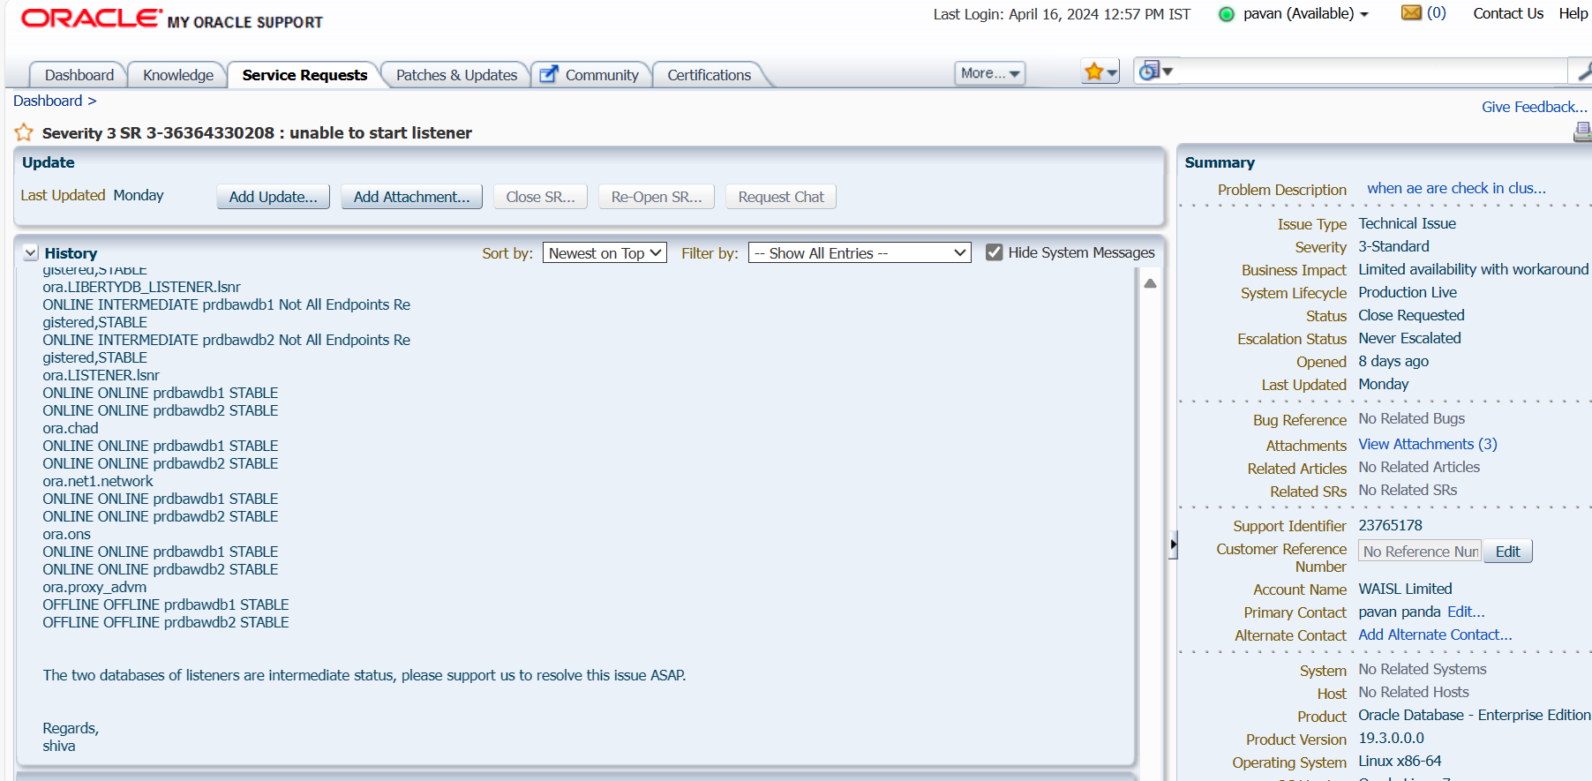

We sent listener status files, ohas, cssd and crsd files to oracle team, they analyzed and suggested to us.

One listener has configured with four ports and rest of listeners also having same port numbers, so need to remove remaining three ports and restart the listeners.

* srvctl config listener (or) srvctl config listener -l <listener_name>

Ex: srvctl config listener (or) srvctl config listener -l LISTENER_BAWSTG

[grid@prdbawdb1 trace]$ srvctl config listener

Type: Database Listener

Network: 1, Owner: grid

Home: <CRS home>

End points: TCP:1521,1527,1528,1529 >>> 4 ports are using for this listener.

Listener is enabled.

Listener is individually enabled on nodes:

Listener is individually disabled on nodes:

Name: LISTENER_BAWSTG

Type: Database Listener

Network: 1, Owner: oracle

Home: /u02/app/oracle/product/19.3.0/dbhome_1 >>> LISTENERS ARE IN ORACLE_HOME

End points: TCP:1529

Listener is enabled.

Listener is individually enabled on nodes:

Listener is individually disabled on nodes:

Name: LISTENER_IMBDB

Type: Database Listener

Network: 1, Owner: oracle

Home: /u02/app/oracle/product/19.3.0/dbhome_1 >>> LISTENERS ARE IN ORACLE_HOME

End points: TCP:1528

Listener is enabled.

Listener is individually enabled on nodes:

Listener is individually disabled on nodes:

Name: LISTENER_LIBERTYDB

Type: Database Listener

Network: 1, Owner: oracle

Home: /u02/app/oracle/product/19.3.0/dbhome_1 >>> LISTENERS ARE IN ORACLE_HOME

End points: TCP:1527

Listener is enabled.

Listener is individually enabled on nodes:

Listener is individually disabled on nodes:

All the listeners enable and running, but one listener has four ports i.e. 1521,1527,1528,1529 and rest of listeners have same port numbers.

* Name: LISTENER

Type: Database Listener

Network: 1, Owner: grid

Home: <CRS home>

End points: TCP:1521,1527,1528,1529 >>> 4 ports are using for this listener.

Listener is enabled.

Listener is individually enabled on nodes:

Listener is individually disabled on nodes:

As per SR request we need modify the listener port numbers follow the below steps.

Connect oracle user and export the SID.

* ps -ef|grep pmon
* export ORACLE_SID= IMBDB1
* sqlplus / as sysdba

Now, check port numbers of listener.

* show parameter local_listener

So, we have to remove excess port numbers i.e 1527,1528,1529

* SQL> alter system set local_listener='(ADDRESS=(PROTOCOL=TCP)(HOST=10.102.123.16)(PORT=1521))','(ADDRESS=(PROTOCOL=TCP)(HOST=10.102.123.16)(PORT=1528))' scope=BOTH SID='IMBDB1';
* show parameter listener

Now, restart the listeners using the command below.

Here, listeners are located at GRID_HOME better switch to grid user.

* su – grid
* password: <grid_password>
* srvctl remove listener -l LIBERTYDB_LISTENER -force  
  srvctl remove listener -l IMBDB_LISTENER -force  
  srvctl remove listener -l BAWDB_LISTENER -force
* srvctl status listener
* lsnrctl status
* srvctl add listener -listener <<LISTENER NAME >> -p "TCP:<<PORT>>"  
  srvctl start listener -listener <<LISTENER NAME >>

[oracle@prdbawdb1 ~]$ srvctl status listener

Listener BAWDB_LISTENER is enabled

Listener BAWDB_LISTENER is running on node(s): prdbawdb2,prdbawdb1

Listener IMBDB_LISTENER is enabled

Listener IMBDB_LISTENER is running on node(s): prdbawdb2,prdbawdb1

Listener LIBERTYDB_LISTENER is enabled

Listener LIBERTYDB_LISTENER is running on node(s): prdbawdb2,prdbawdb1

Listener LISTENER is enabled

Listener LISTENER is running on node(s): prdbawdb2,prdbawdb1

[oracle@prdbawdb1 ~]$

[oracle@prdbawdb1 ~]$ srvctl config listener

Name: BAWDB_LISTENER

Type: Database Listener

Network: 1, Owner: grid

Home: <CRS home>

End points: TCP:1529

Listener is enabled.

Listener is individually enabled on nodes:

Listener is individually disabled on nodes:

Name: IMBDB_LISTENER

Type: Database Listener

Network: 1, Owner: grid

Home: <CRS home> >>> Changes to Grid_Home

End points: TCP:1528

Listener is enabled.

Listener is individually enabled on nodes:

Listener is individually disabled on nodes:

Name: LIBERTYDB_LISTENER

Type: Database Listener

Network: 1, Owner: grid

Home: <CRS home> >>> Changes to Grid_Home

End points: TCP:1527

Listener is enabled.

Listener is individually enabled on nodes:

Listener is individually disabled on nodes:

Name: LISTENER

Type: Database Listener

Network: 1, Owner: grid

Home: <CRS home> >>> Changes to Grid_Home

End points: TCP:1521

Listener is enabled.

Listener is individually enabled on nodes:

Listener is individually disabled on nodes:

* srvctl status listener

* srvctl config listener

* Lsnrctl status

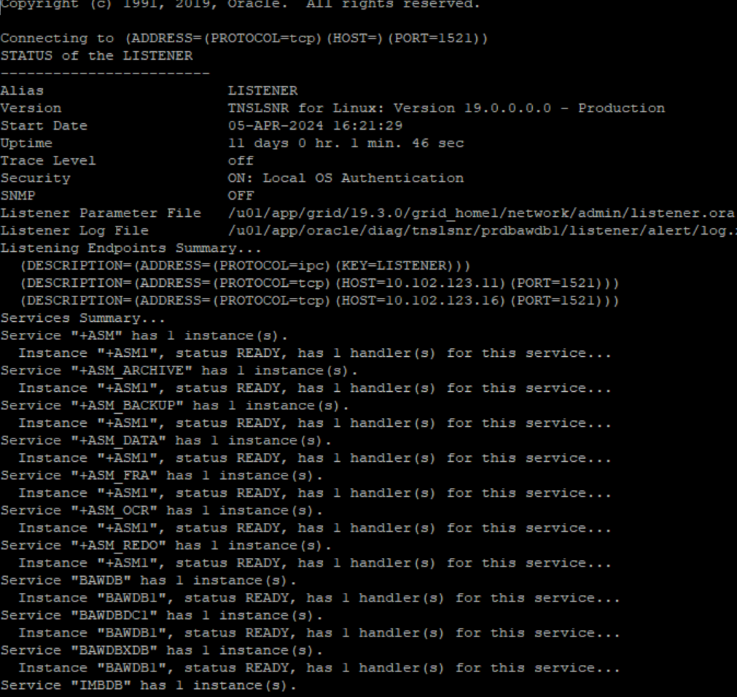

Now, check the status of cluster local resources of listener.

* crsctl stat res -t

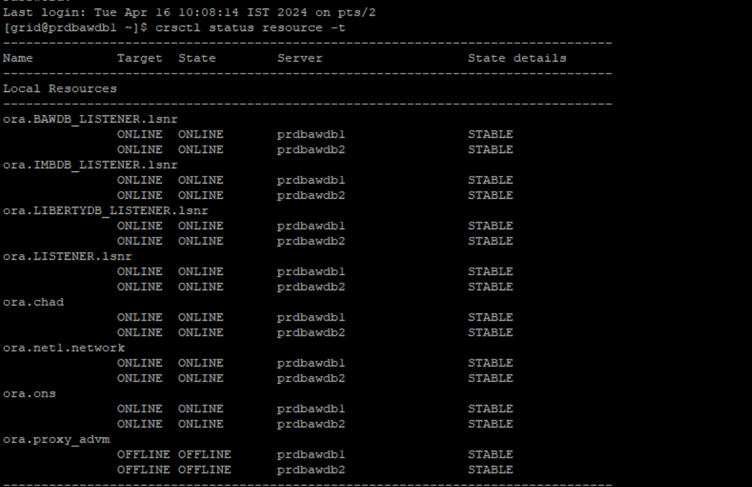

Hence, ora.listener.lsnr resources of state is showing ONLINE.